Anthony Cunningham

Experimental Design & Analysis

4/11/18

**Homework 8 R Code and Output**

1)

bottleFill <- read.table("http://www.stat.uiowa.edu/~ernli/DOEdata/problem0624.txt", header = TRUE)

bottleFill$C <- ifelse(bottleFill$Carbonation == 10, -1, 1)

bottleFill$P <- ifelse(bottleFill$Pressure == 25, -1, 1)

bottleFill$S <- ifelse(bottleFill$Speed == 200, -1, 1)

bottleFill

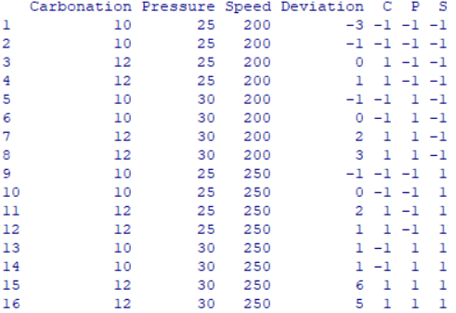

bottleFillLM = lm(Deviation ~ C*P*S, bottleFill)

summary(aov(bottleFillLM))

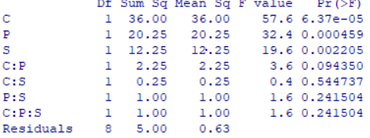

summary(bottleFillLM)

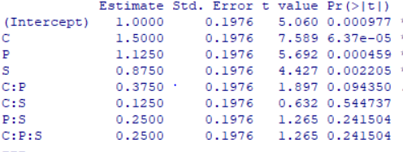

library(gplots)

qqnorm(aov(bottleFillLM), label = TRUE)



bottleFillReduced = lm(Deviation ~ C + P + S + C:P, bottleFill)

summary(aov(bottleFillReduced))

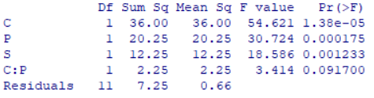

summary(bottleFillReduced)

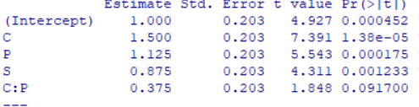

lackOfFitTestLM = lm(Deviation ~ C + P + S + C:P + factor(C):factor(P):factor(S), bottleFill)

summary(aov(lackOfFitTestLM))

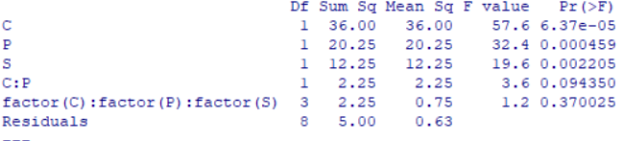

par(mfrow = c(2,2))

plot(aov(bottleFillReduced))



2)

uec <- read.table("http://www.stat.uiowa.edu/~ernli/DOEdata/problem0626.txt", header = TRUE)

uecLM = lm(UEC ~ Laser*Pulse*Cell*Writing, uec)

summary(uecLM)

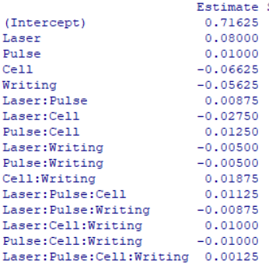

library(gplots)

qqnorm(aov(uecLM), label = TRUE)



effs = 2*coef(uecLM)[-1]

PSE = function(e) {

abseff = abs(e)

s0 = 1.5*median(abseff)

1.5*median(abseff[abseff<2.5*s0])

}

cbind(effs, pseudo.t = effs/PSE(effs))

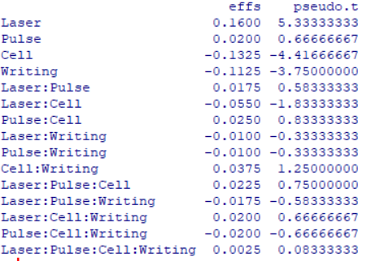

uecCollapsed = lm(UEC~Laser*Cell*Writing, uec)

summary(aov(uecCollapsed))

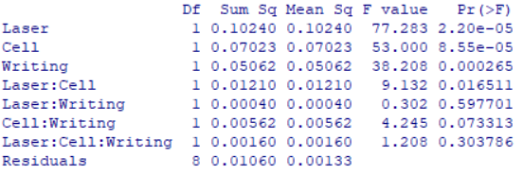

uecReduced = lm(UEC ~ Laser + Cell + Writing + Laser:Cell + Cell:Writing, uec)

summary(uecReduced)

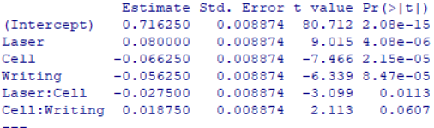

3)

uec27 <- read.table("http://www.stat.uiowa.edu/~ernli/DOEdata/problem0627.txt", header = TRUE)

uec27LM = lm(UEC ~ Laser*Pulse*Cell*Writing + I(Laser^2) + I(Pulse^2) + I(Cell^2) + I(Writing^2), uec27)

(effs = 2*coef(uec27LM)[-1])

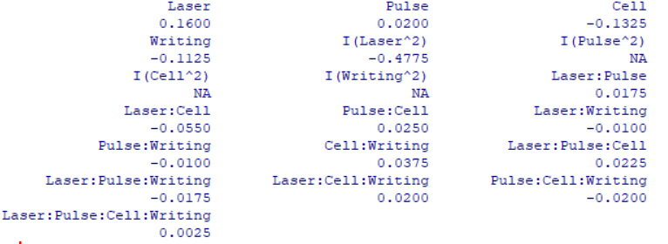

qqnorm(aov(uec27LM), label = TRUE)



effs = 2*coef(uecLM)[-1][-7][-8][-9]

PSE = function(e) {

abseff = abs(e)

s0 = 1.5*median(abseff)

1.5*median(abseff[abseff<2.5*s0])

}

cbind(effs, pseudo.t = effs/PSE(effs))

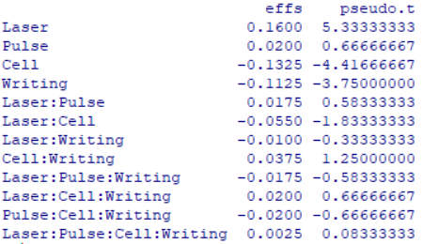

summary(aov(uec27LM))

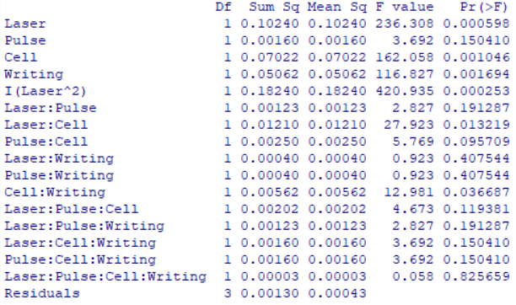

uec27Reduced = lm(UEC ~ Laser*Cell + Cell*Writing + I(Laser^2) + I(Cell^2) + I(Writing^2), uec27)

summary(aov(uec27Reduced))

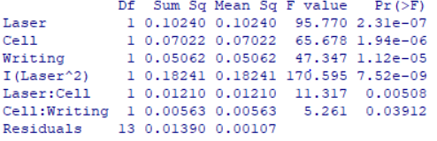

uec27LackOfFit = lm(UEC ~ Laser*Cell + Cell*Writing + I(Laser^2) + I(Cell^2) + I(Writing^2) + factor(Laser):factor(Pulse):factor(Cell):factor(Writing), uec27)

summary(aov(uec27LackOfFit))

